Workbook 1

1. Run command rosrun rospy_tutorials talker
2. rostopic list
3. rostopic echo /chatter

Exercise: Now run rosrun roscpp_tutorials talker

Exercise: roscd rospy_tutorials

& find the python talker file using nano editor

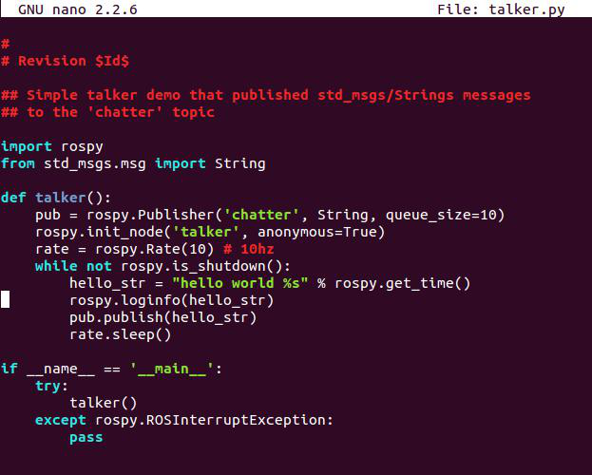

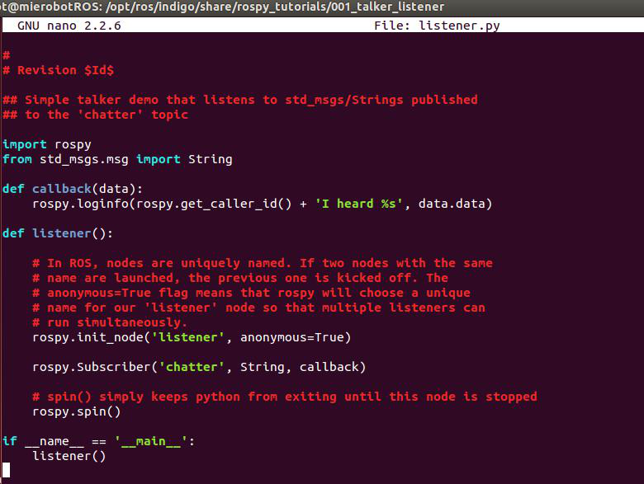

Exercise: Run RQT graph as below with rosrun rqt_graph rqt_graph

